Test Case: tc005_SPX_Dev5_Crear_Requisicion_Spot_Con_FAD_Tipo_Cobro_Project
Step 1 - Enter username and password and click to button Enter: Credentials Entered
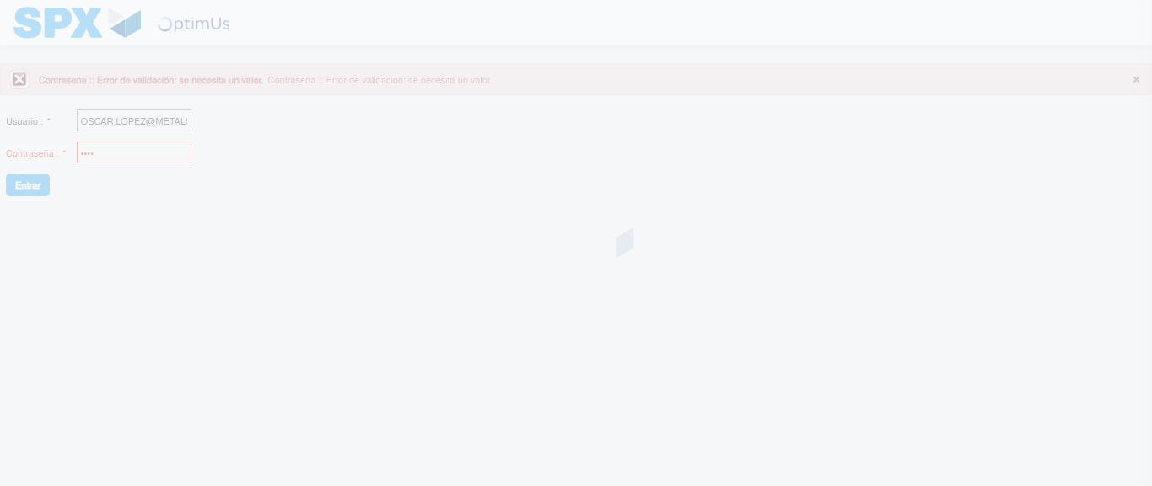Image file-name: QC_Testing-tc005_SPX_Dev5_Crear_Requisicion_Spot_Con_FAD_Tipo_Cobro_Project-1784570219837

Step 2 - Select to UEN and Access to Spot Buy Requisitions : UEN Correctly selected and Correct access
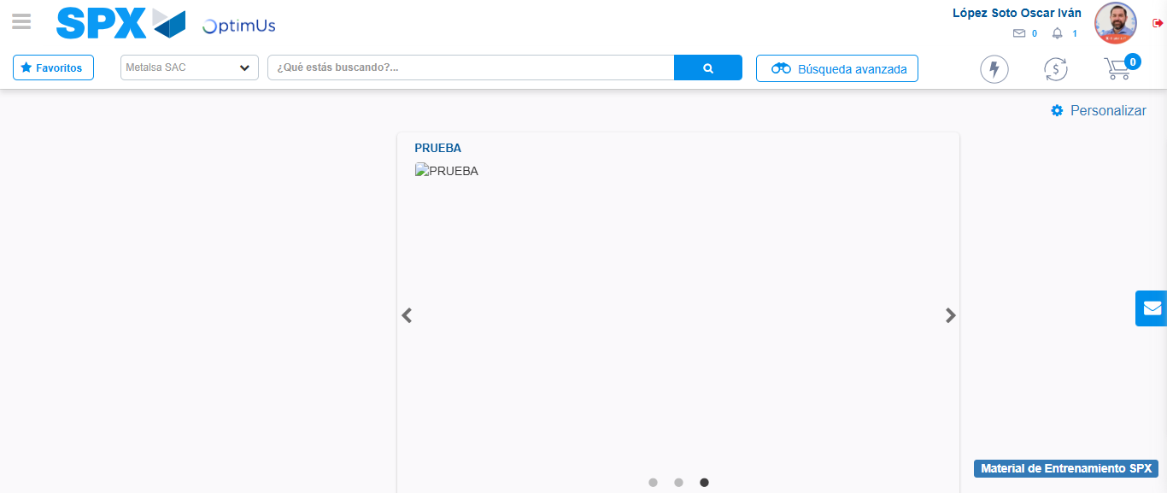Image file-name: QC_Testing-tc005_SPX_Dev5_Crear_Requisicion_Spot_Con_FAD_Tipo_Cobro_Project-1784570286058

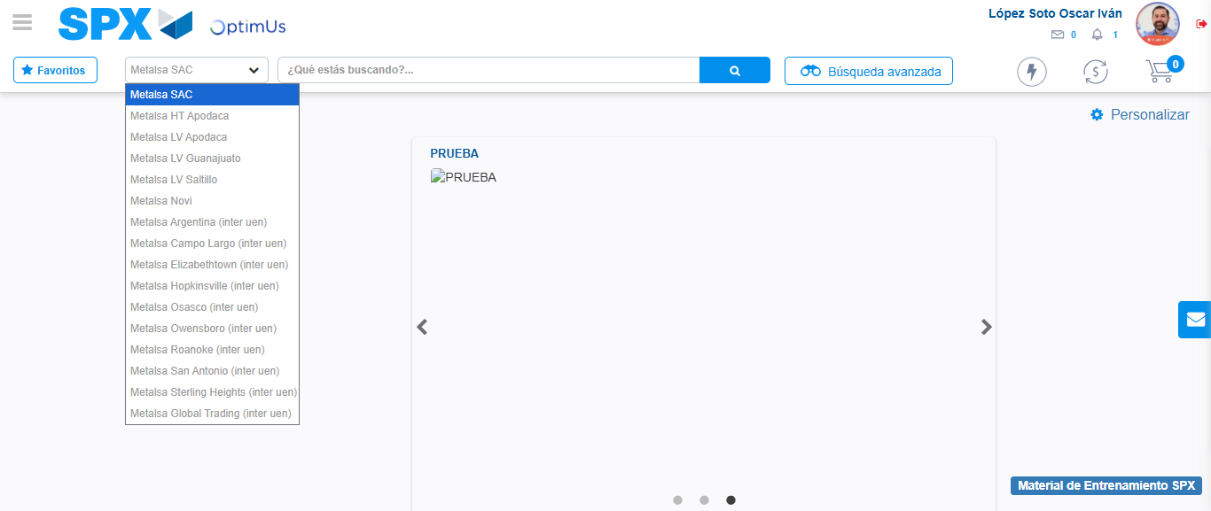Image file-name: QC_Testing-tc005_SPX_Dev5_Crear_Requisicion_Spot_Con_FAD_Tipo_Cobro_Project-1784570288886

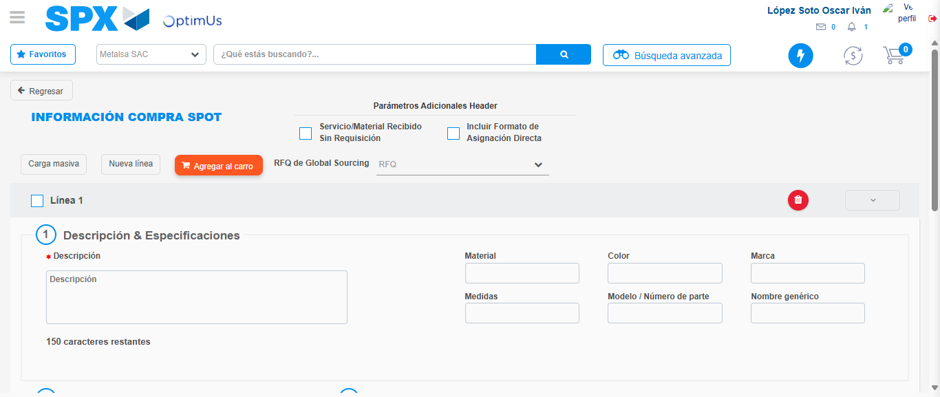Image file-name: QC_Testing-tc005_SPX_Dev5_Crear_Requisicion_Spot_Con_FAD_Tipo_Cobro_Project-1784570315971

Step 3 - Add FAD to Requisition: FAD Successfully Added
Image file-name: QC_Testing-tc005_SPX_Dev5_Crear_Requisicion_Spot_Con_FAD_Tipo_Cobro_Project-1784570316287

Image file-name: QC_Testing-tc005_SPX_Dev5_Crear_Requisicion_Spot_Con_FAD_Tipo_Cobro_Project-1784570316520

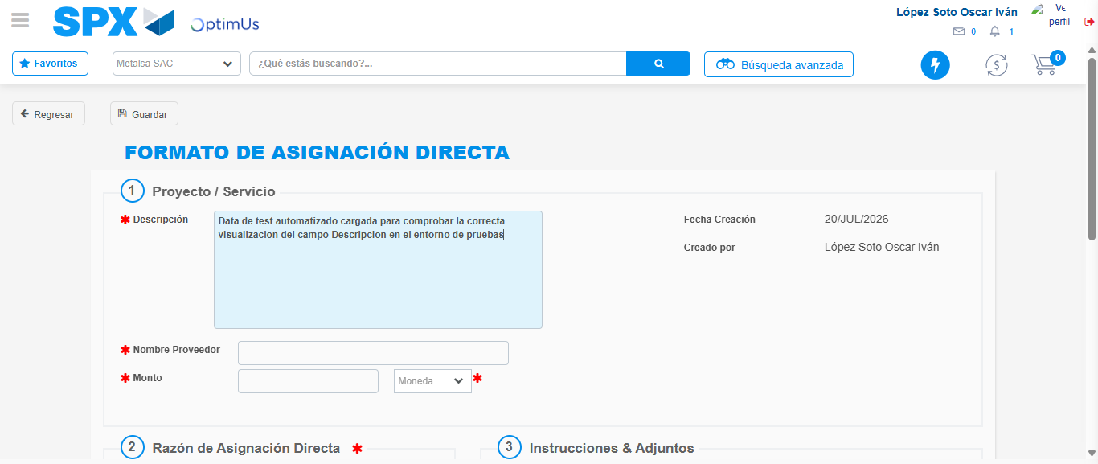Image file-name: QC_Testing-tc005_SPX_Dev5_Crear_Requisicion_Spot_Con_FAD_Tipo_Cobro_Project-1784570319774

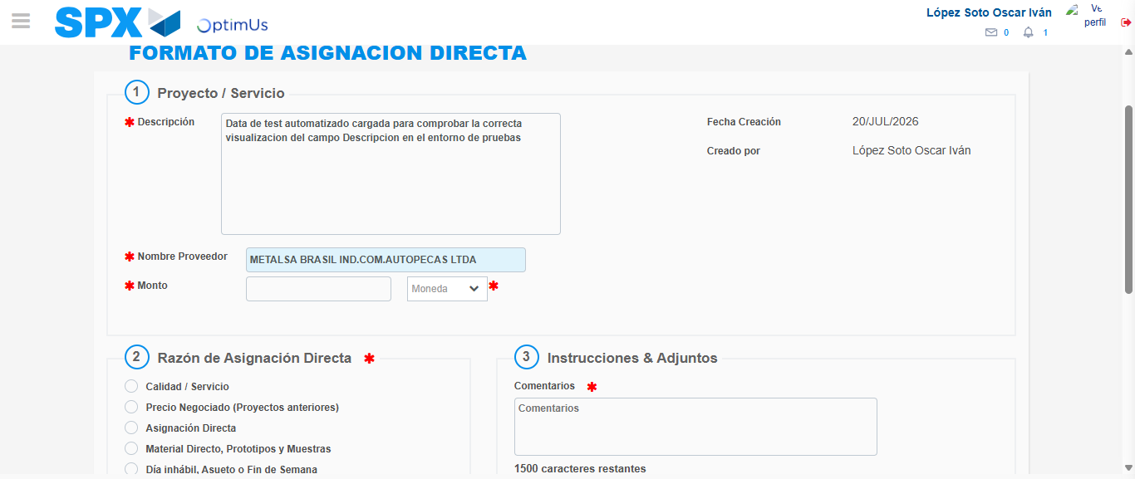Image file-name: QC_Testing-tc005_SPX_Dev5_Crear_Requisicion_Spot_Con_FAD_Tipo_Cobro_Project-1784570326583

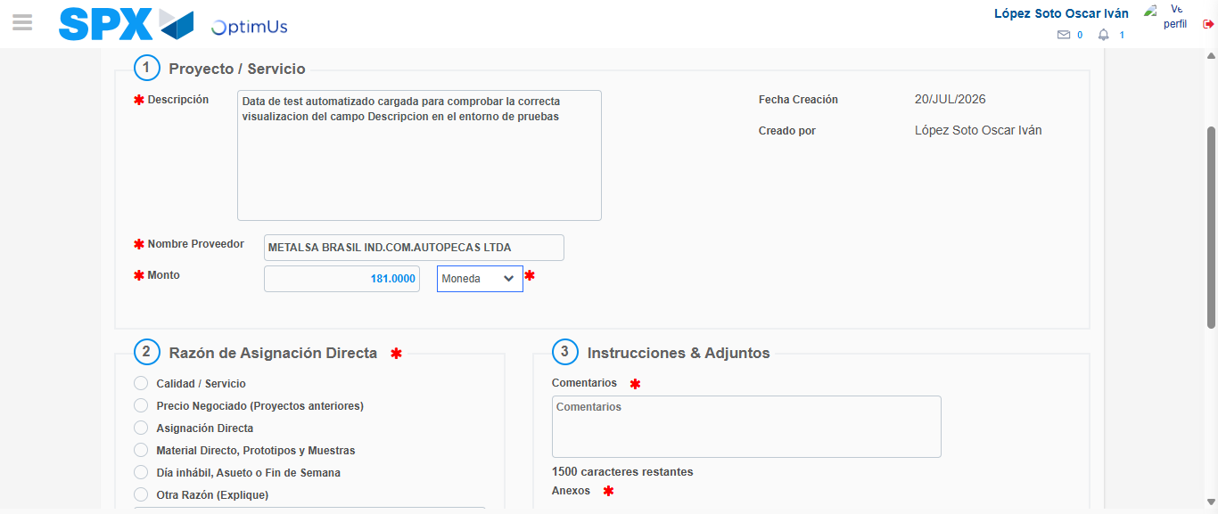Image file-name: QC_Testing-tc005_SPX_Dev5_Crear_Requisicion_Spot_Con_FAD_Tipo_Cobro_Project-1784570327202

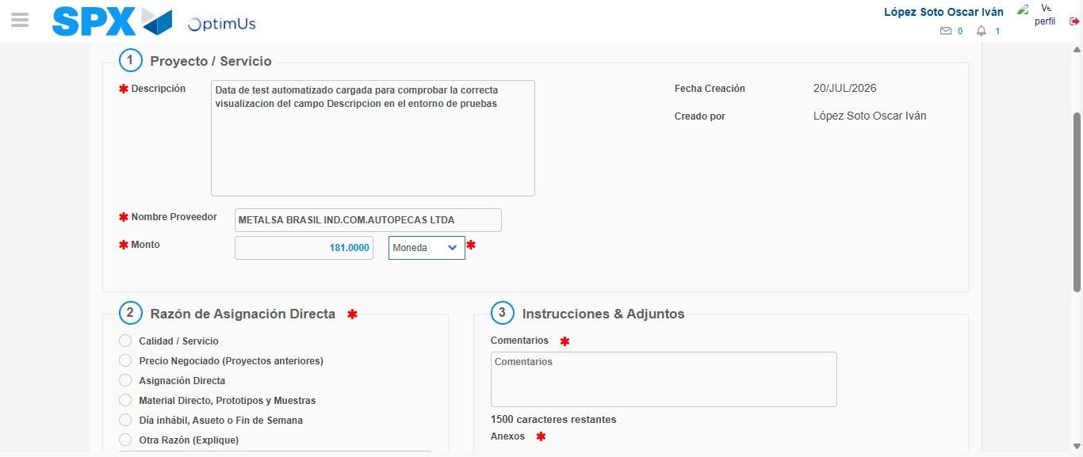Image file-name: QC_Testing-tc005_SPX_Dev5_Crear_Requisicion_Spot_Con_FAD_Tipo_Cobro_Project-1784570327443

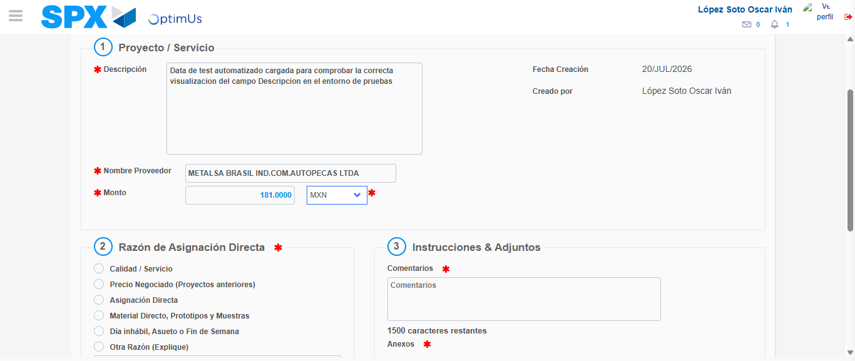Image file-name: QC_Testing-tc005_SPX_Dev5_Crear_Requisicion_Spot_Con_FAD_Tipo_Cobro_Project-1784570327995

Image file-name: QC_Testing-tc005_SPX_Dev5_Crear_Requisicion_Spot_Con_FAD_Tipo_Cobro_Project-1784570328216

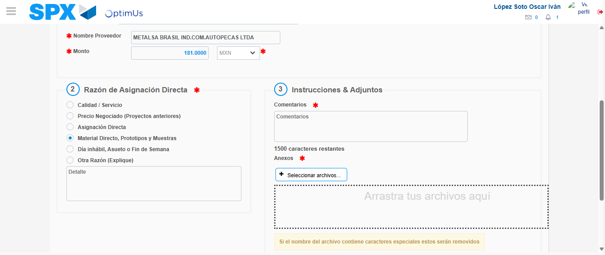Image file-name: QC_Testing-tc005_SPX_Dev5_Crear_Requisicion_Spot_Con_FAD_Tipo_Cobro_Project-1784570329239

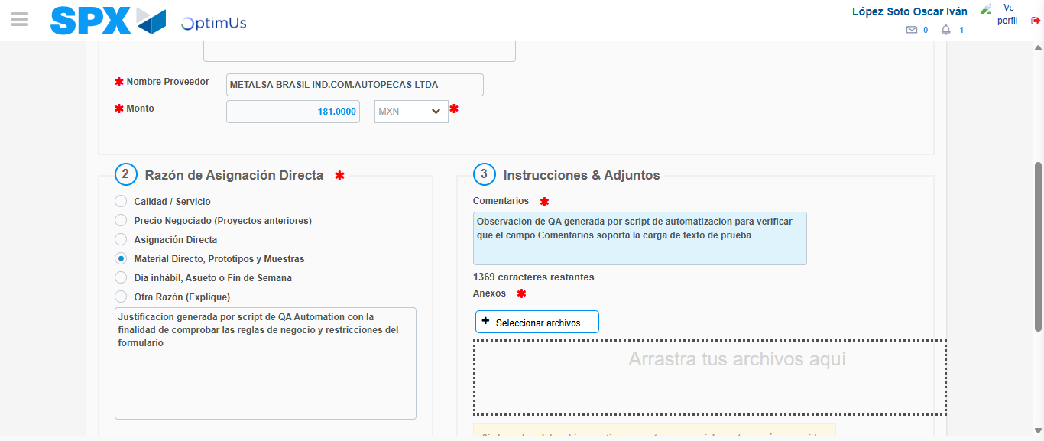Image file-name: QC_Testing-tc005_SPX_Dev5_Crear_Requisicion_Spot_Con_FAD_Tipo_Cobro_Project-1784570340778

Image file-name: QC_Testing-tc005_SPX_Dev5_Crear_Requisicion_Spot_Con_FAD_Tipo_Cobro_Project-1784570341731

Step 4 - Data Capture Spot Buy Requisition: Data captured correctly
Image file-name: QC_Testing-tc005_SPX_Dev5_Crear_Requisicion_Spot_Con_FAD_Tipo_Cobro_Project-1784570316287

Image file-name: QC_Testing-tc005_SPX_Dev5_Crear_Requisicion_Spot_Con_FAD_Tipo_Cobro_Project-1784570316520

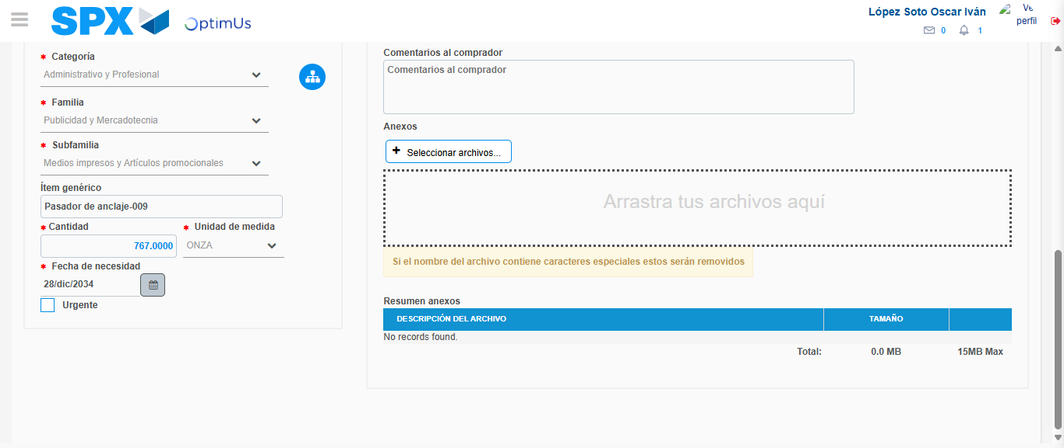Image file-name: QC_Testing-tc005_SPX_Dev5_Crear_Requisicion_Spot_Con_FAD_Tipo_Cobro_Project-1784570356525

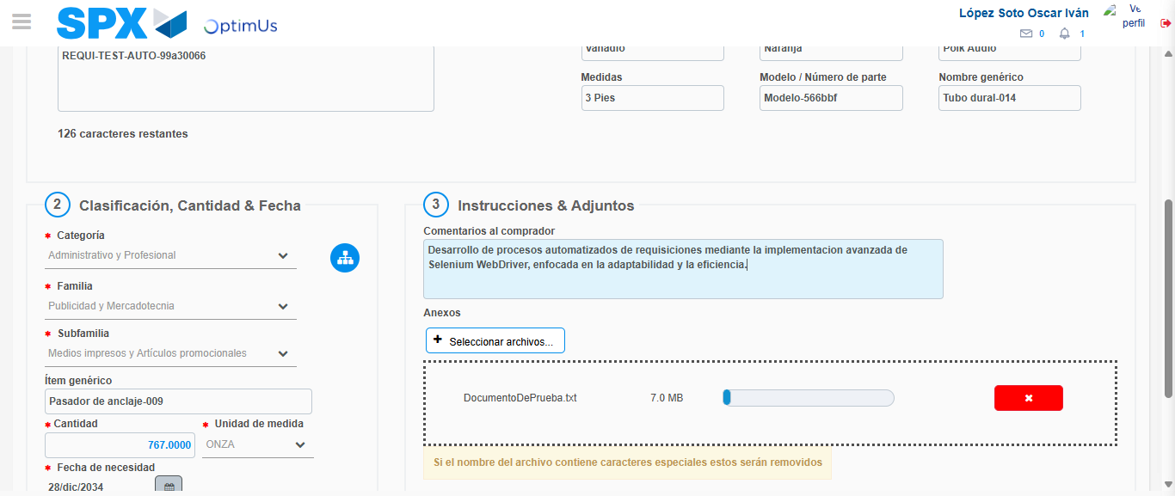Image file-name: QC_Testing-tc005_SPX_Dev5_Crear_Requisicion_Spot_Con_FAD_Tipo_Cobro_Project-1784570357459

Step 8 - Return to Main Page SPX : Return to Main Page SPX
Image file-name: QC_Testing-tc005_SPX_Dev5_Crear_Requisicion_Spot_Con_FAD_Tipo_Cobro_Project-1784570286058

Image file-name: QC_Testing-tc005_SPX_Dev5_Crear_Requisicion_Spot_Con_FAD_Tipo_Cobro_Project-1784570288886

Image file-name: QC_Testing-tc005_SPX_Dev5_Crear_Requisicion_Spot_Con_FAD_Tipo_Cobro_Project-1784570315971

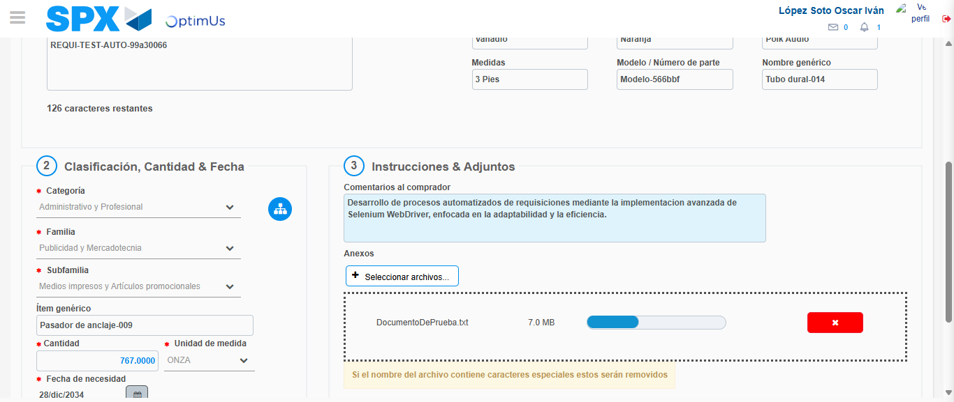Image file-name: QC_Testing-tc005_SPX_Dev5_Crear_Requisicion_Spot_Con_FAD_Tipo_Cobro_Project-1784570359733

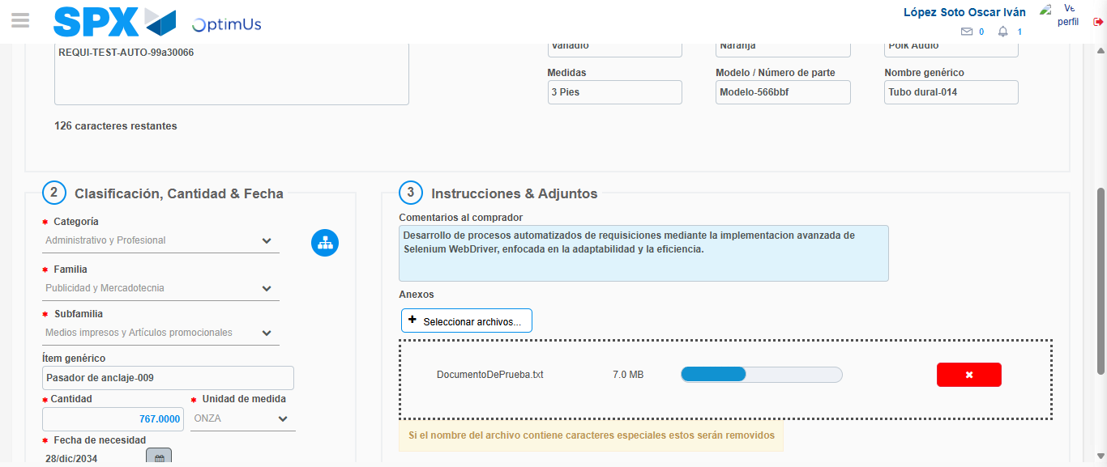Image file-name: QC_Testing-tc005_SPX_Dev5_Crear_Requisicion_Spot_Con_FAD_Tipo_Cobro_Project-1784570359948

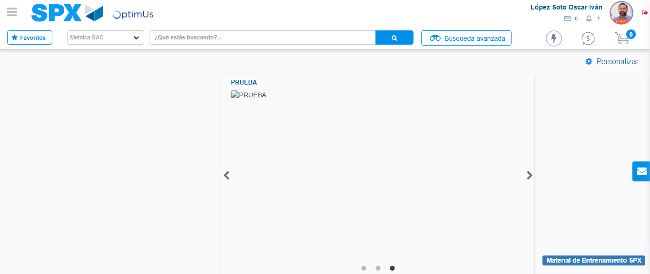Image file-name: QC_Testing-tc005_SPX_Dev5_Crear_Requisicion_Spot_Con_FAD_Tipo_Cobro_Project-1784570381320

Step 9 - Log Out : Log Out SPX
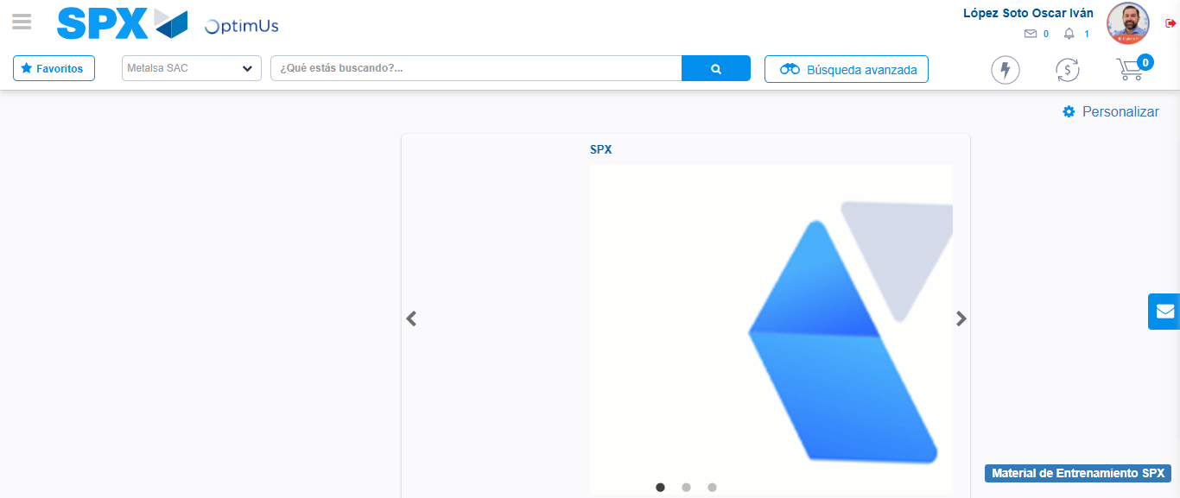Image file-name: QC_Testing-tc005_SPX_Dev5_Crear_Requisicion_Spot_Con_FAD_Tipo_Cobro_Project-1784570381677

